**OOP THEORY CASE STUDY**

**OFFICE SUPPLY ORDERING SYSTEM**

***(OSO) SYSTEM***

***GROUP MEMBER :***

***Syed Ali Hassan (cs201140)***

***Syed Muhammad Omer (cs201144)***

***Muhammad HassanUllah Khan (cs201086)***

**BASIC OVERVIEW OF CLASS FUNCTIONALITY**

**Employee**

***So! Here in Office Supply Ordering system first the user have to log in it’s purchaser (employee) class if Department manager to the Department Manager class Purchaser is allowed to view list of supply, Filter it by giving category (for example : It Department)***

***And allowed to request supplies from the above catalog given there In the end user can log out of System. .***

**Department Manager**

**Now to the class of Department manager Department Manager can Request general supply And also review the supply request given by employee class. After reviewing He/she can Approve or Deny requests. If he/she deny request then h or she will give the reason of Denial last but not the least he/she can track Spending.**

**Ordering System**

**When the request is approved or requested by manager supply request class will create a .TXT file**

**Supply Vendor**

**When Order will be received it will receive document from .TEXT document, analyse document and sets it in queue. When order is being checked it will mark its status To fulfilled and ready to take away other wise status prompt (Pending).**

Now Identifying Classes

**There are some main classes :**

**Employee . Product .**

**Department manager . Product catalog .**

**Order . General.**

**Order item. Record.**

**We Have added General class for classes having the same method. And record class to add document order**

**Classes and its attributes**

**Employee**

* Employee id Login name Password Department First name Last name

**Department**

Department Manager Contain All Attributes of Employee as it inherits employee.

**Order:**

Order number Order date Order status

**Flow Of Program And It’s Retation**

Employee can have multiple Order objects (one to many relation)

ProductCatalog is associated with multiple Product objects(one to many relation)

A Department Manager is an Employee.(Is-A Relation)

Order is associated with one Employee(many to one relation)

**Uml Diagram:**

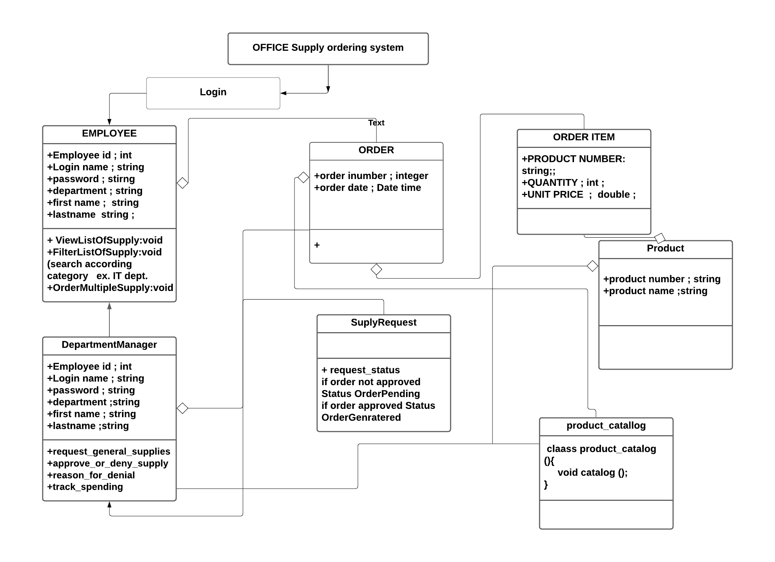

**OUTPUT SCREENSHOT**

**Here You can Login As User Employee Or as DepartmentManager**

**Login Condition Are Precondition.**

**Now it Display menu function having All Functionality here we are viewing list of supply**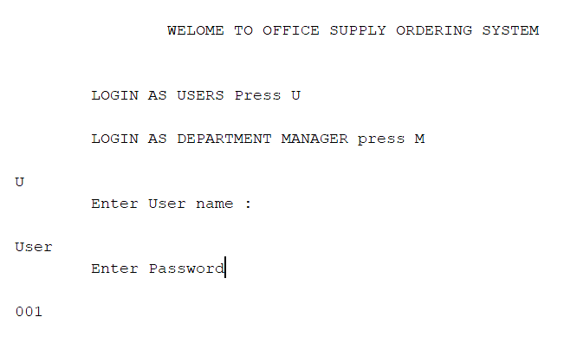

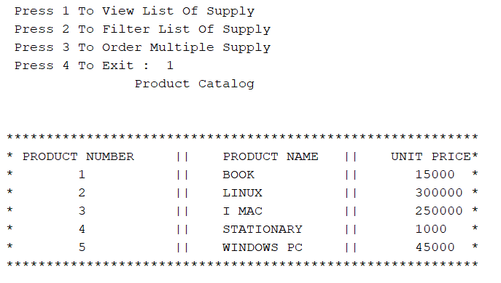

**Now it Display menu function having All Functionality now for Filter list of Supplies By Product Category:**

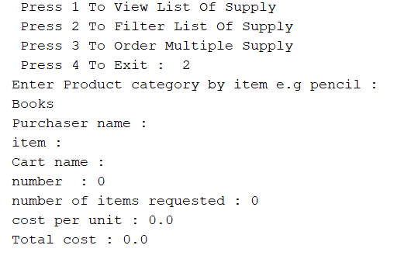

**It filters From Book Category as .text document has**

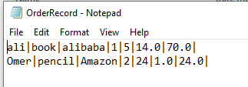

**Now it Display menu function having All Functionality now for Order Supplies:**

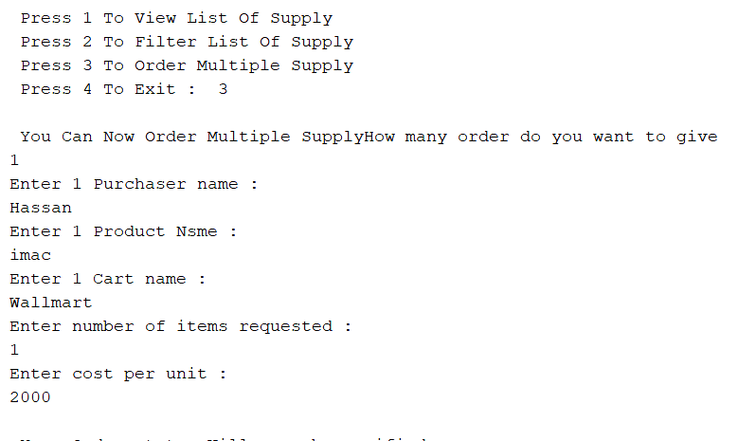

**Now Order has been Added**

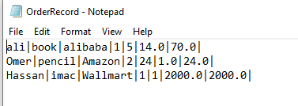

**Added:**

**Now For Department Manager:**

**Here You can Login As DepartmentManager**

**Login Condition Are Precondition.**

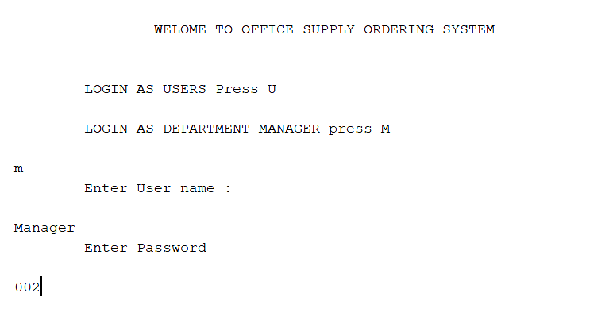

**Now it Display menu function having All Functionality now for**

**Approve Or Deny Request :**

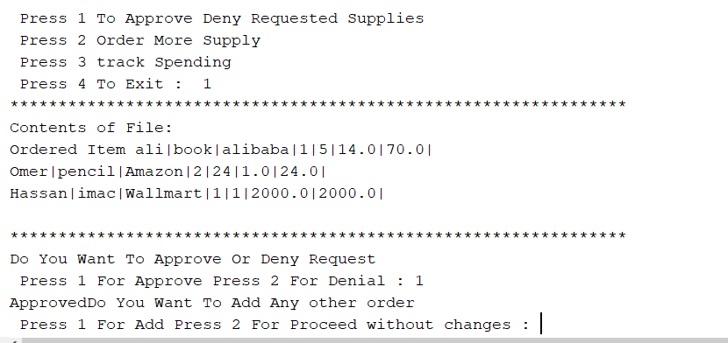

**If Denied :**

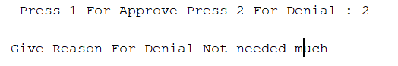

**Now it Display menu function having All Functionality now for**

**Order multiple Supply :**

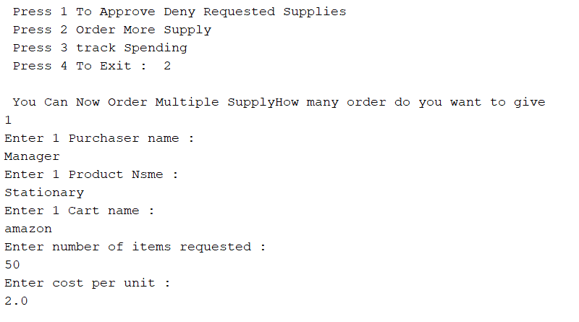

**This Order is Then Proceed to Supply vendor:**

**Supply vendor :**

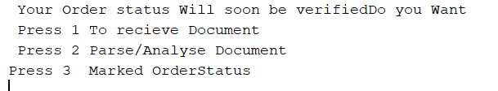

**Receive Document :**

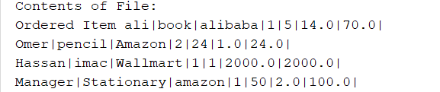

**All order receive by Supply Vendor**

**Parse Document:**

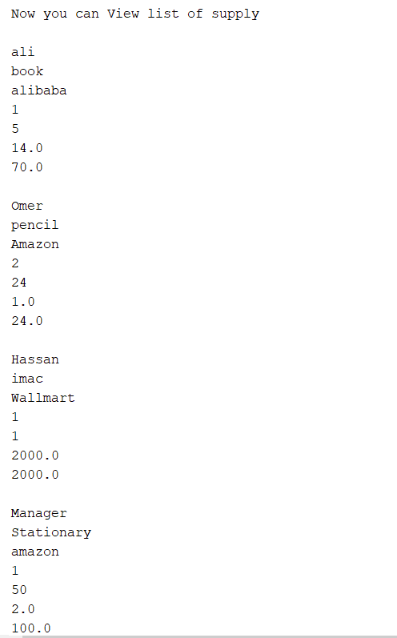

**Order has been Analysed and set into Order**

**Mark Status**

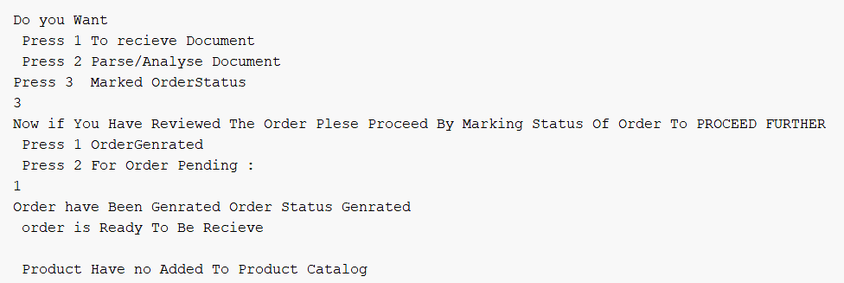

**If order status is not responded order status (PENDING)**

IT IS THEN HEADED TOWARD PRODUCT WHERE PRODUCT ARE ADDED IN PRODUCT CATALOG.